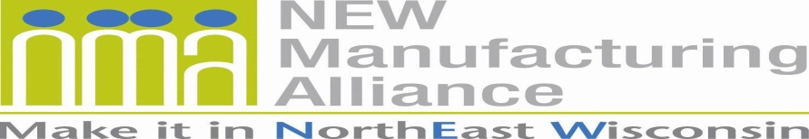

Membership Application

MANUFACTURER ANNUAL DUES STRUCTURE – Based on the total number of northeast Wisconsin employees:
1 to 50 - $750
51 to 250 - $950
251 to 500 - $1,250
501 or Greater - $2,000

ASSOCIATE Member Annual Dues: $2,500
AFFILIATE Member Annual Dues: $0

For membership questions, please contact Ann Franz at ann.franz@nwtc.edu or phone (920) 498-5587.

Today’s Date: Click or tap to enter a date.
Type of Membership: Choose an item.
Number of employees in northeast Wisconsin: Enter text.
Company / Organization Name: Enter text.
Address Line One: Enter text.
Address Line Two: Enter text. |  |  |  |  | County: Enter text.
City: Enter text. | State: Enter text. |  |  |  | Zip: Enter text.
Telephone with Area Code: Enter text. |  |  |  | Website Address: Enter text.
Products Manufactured and/or Services Provided: Enter text.
An invoice will be USPS mailed to the primary contact, unless otherwise indicated.
PRIMARY CONTACT’S First & Last Name: Enter text.
Primary Contact’s Title: Enter text. |  | Primary Contact’s Email: Enter text.
HUMAN RESOURCE (HR) CONTACT’S First & Last Name: Enter text.
HR Contact’s Title: Enter text. |  |  | HR Contact’s Email: Enter text.
ADDITIONAL CONTACT’S First & Last Name: Enter text.
Additional Contact’s Title: Enter text. |  |  | Additional Contact’s Email: Enter text.
Describe your business/organization and how it supports manufacturing: Enter text.
Manufacturer Outreach Activities - As a means to connect with K-16, the Alliance encourages its members to participate in outreach. Select the K-16 outreach activities you are interested in participating.

☐ Career Speakers
☐ College Internships & Co-ops
☐ Job Shadowing
☐ Mentoring
☐ Plant Tours
☐ Youth Apprenticeship

☐ I authorize the Alliance to link my organization’s website and manufacturer outreach activities (if any selected above) on its website.

☐ I do NOT authorize the Alliance to link my organization’s website or its manufacturer outreach activities (if any selected above) on its website.

Below are topics the Alliance is working on. Select any that interest you.

☐ Changing the Image of Manufacturing Careers
☐ Grow Partnerships (connecting with K-16, media, and manufacturers)
☐ Workforce Development

My company is interested in a complimentary joint membership in the North Coast Marine Manufacturing Alliance (NCMMA – www.northcoastmma.com). ☐ YES ☐ NO

Who referred you to join the NEW Manufacturing Alliance? Enter text.

Please email the completed application to
Ann Franz, executive director, ann.franz@nwtc.edu.
Your company/organization will be contacted within two business days.

Thank you for your interest in joining the
NEW Manufacturing Alliance!

www.newmfgalliance.org

